Skupina výtvarných umělců (The Group of Fine Artists)

Skupina výtvarných umělců (The Group of Fine Artists) was an avant-garde artist group active in Prague in the years 1911-1917. Skupina consisted of Czech painters, sculptors, architects, designers, illustrators, art historians and art critics. Many of Skupina’s members seceded from the Mánes Union, Prague’s dominant association for modern art, to form the new group. The foundational meeting in May 1911 was attended by Emil Filla, Josef Gočár, Otto Gutfreund, Pavel Janák, Vlastislav Hofman, František Kysela, Zdeněk Kratochvíl, Ladislav Šíma, and Václav Špála. These founders were joined by Vratislav Brunner, Josef Chochol, Vilém Dvořák, František Langer, Jan Thon, Vincenc Beneš, Josef Čapek and his art critic brother Karl Čapek, with the later additions of Antonín Procházka and art historians Vincenc Kramář and V. V. Štech. Predecessors to the group can be found in the inclusiveness and expressive aims of Osma (The Eight; 1907-1908), some of whose former members joined Skupina, and in the spiritual orientation of a Czech fin-de-siècle art that had absorbed the ethos of vernacular Gothic and Baroque.

Skupina helped launch a Czech variant of Cubism in the fine and applied arts. The group’s implicit aim was to transform urban life through modern art and design, an ideal that recalls the English Arts & Crafts Movement and foreshadows the Bauhaus in Germany. This metamorphosis, however, was dependent upon Czech responses to Parisian Cubism. A pivotal role was played by the art historian Vincenc Kramář who opened to Prague artists his private collection of works by Old Masters and modernists including Pablo Picasso and Georges Braque, the latter portion amassed between 1910 and 1914. Kramář even facilitated direct contact between Czech artists and Picasso in Paris. Skupina members also maintained connections to Germany, exhibiting with the Neue Secession in Berlin in 1911, the Sonderbund in Cologne in 1912, and in 1913 at Munich’s Galerie Neue Kunst and Herwarth Walden’s Der Sturm in Berlin. Czech Cubism passed through stages of development which contributed to a split within Skupina. In its early manifestation Czech Cubism closely emulated Parisian Cubism, with most Skupina members following Picasso, Braque, and Juan Gris while some Mánes members followed the these artists as well as Salon Cubists around Albert Gleizes and Jean Metzinger. This emulation of Parisian Cubism then merged with subjects specific to the Czech context. Internal division within Skupina erupted in November/December, 1912, over the question of how closely to follow Picasso’s example, with Filla advocating absolute emulation and others demanding more flexible interpretation. As a result, group members Brunner, the Čapek brothers, Hofman, Chochol, Šíma, and Špála left Skupina and rejoin Mánes.

Alongside group exhibitions Skupina sought additional ways reach a broad audience. Their journal Umělecký Měsíčník (Arts Monthly) was founded in October 1911. First edited by Josef Čapek, then by Pavel Janák and František Langer after April 1912, it published essays by Skupina members and progressive-minded cultural commentators. Offerings included exhibition reviews, publication reviews, theoretical essays, and opinion pieces, most of which were richly illustrated. The journal sold advertising spots to local businesses and reader subscriptions to fund publication. Architects and designers of Skupina also participated in organizations that advocated for quality in the applied arts. Both the Czech applied art cooperative Artěl, founded in 1908 and modeled on the Wiener Werkstätte, and the Pražské umělecké dílny (P.U.D., or Prague Art Workshops), founded in 1912 by Skupina members Gočár, Chochol, and Janák with Odolen Grégr, served avant-garde designers and progressive consumers as an outlet for the design and production of modern furniture and applied arts.

The Great War interrupted the exhibition activities of Skupina and their journal Umělecký Měsíčník ceased publication. The group slowly dissolved as members took individual paths. Filla immigrated to the Netherlands to join the resistance; Gutfreund volunteered as a medic in the Austro-Hungarian military and was taken as POW; some former Skupina members rejoined Mánes; and many continued their practice independently in the Czech lands. The legacy of Skupina can be seen in the artists’ and designers’ mature styles in the late 1910s and 1920s, in Rondo-Cubist architecture of the 1920s, and in the art of Devětsil pursuing Czech Surrealist Poeticism in 1920s-30s Prague.

Skupina exhibitions:

- 1st exhibition held January 5 – March 1, 1912, in Prague’s Obecní dům (Municipal House) with works by Josef Gočár, Vlastislav Hofman, Josef Chochol, Pável Janák, Josef Rosipal, Otto Gutfreund, Vratislav Brunner, Ladislav Šíma, Václav Špála, František Kysela, Josef Čapek, Vincenc Beneš, Zdeněk Kratochvíl, Emil Filla, and Antonín Procházka.
- 2nd exhibition held September 28 – end of November, 1912, in Prague’s Obecní dům with works by Skupina and former Osma artists Beneš, Čapek, Feigl, Filla, Gočár, Gutfreund, Hofman, Chochol, Janák, Kratochvíl, Nowak, Procházka, Šíma and Špála; the Fauve artists André Derain and Othon Friesz; and Brücke artists Erich Heckel, Ernst Ludwig Kirchner, Otto Mueller, and Karl Schmidt-Rottluff.
- 3rd exhibition held April 5 – April16, 1913, at the Galerie Neue Kunst in Munich, featuring Beneš, Filla, Gutfreund, Procházka, Gočár, and Janák.
- 4th exhibition held May – June, 1913, in Prague’s Obecní Dům included Skupina artists and international guests Derain, Georges Braque, Pablo Picasso, Juan Gris, and Ardengo Soffici, plus a section of art from East Asia and Africa and over a hundred works of folk art.
- 5th exhibition held September 20 – November 1, 1913, at Herwarth Walden’s Galerie Der Sturm in Berlin, featuring Beneš, Filla, Gočár, Gutfreund, Janák, Procházka, and Otokar Kubín.
- 6th exhibition held February – March, 1914, in Prague’s Obecní Dům featuring Beneš, Filla, Gočár, Gutfreund, Janák, Kratochvíl, Otakar Nejedlý, Procházka, Braque, Derain, Munch, Pechstein, Picasso, and five African sculptures. Simultaneous with Skupina’s 6th exhibition, the Mánes Union staged the counter-exhibition “Modern Art” (February – March, 1914) organized by André Mercereau and including Czech artists Josef Čapek, Hofman, Chochol, Kubín, Kubišta, Šíma, Špála and international artists Alexander Archipenko, Constantin Brancusi, Robert Delaunay, Raymond Duchamp-Villon, Raoul Dufy, Othon Friesz, Albert Gleizes, Roger de la Fresnaye, Louis Marcoussis, Jean Marchand, Jean Metzinger, Piet Mondrian, Diego Rivera, and Jacques Villon.

Key Bibliographic Sources

Benson, Timothy O. and Éva Forgács, eds. Between Worlds: A Sourcebook of Central European Avant-Gardes, 1910-1930 (Cambridge, Mass.: MIT Press, 2002).

Lahoda, Vojtěch. Český Kubismus (Prague: Brana, 1996).

Lamač, Miroslav. Osma a Skupina (Prague: Odeon, 1988).

Mansbach, Steven A. Modern Art in Eastern Europe: From the Baltic to the Balkans, ca. 1890-1939 (Cambridge: Cambridge University Press, 1999).

Padrta, Jiří with Miroslav Lamač. Osma a Skupina výtvarných umělců – 1907-1917: Teorie, Kritika, Polemika (Prague: Odeon, 1992).

Švácha, Rostislav, ed. The Pyramid, the Prism and the Arc: Czech Cubist Architecture 1911-1923 (Prague: Gallery, 2000).

Švestka, Jiří and Tomáš Vlček, with Pavel Liška, eds. Czech Cubism 1909-1925: Art, Architecture, Design (translation of 1991 original). (Prague: i3 CZ Modernista, 2006).

Uhrová, Olga and Vojtěch Lahoda, eds. Vincenc Kramář. From Old Masters to Picasso, exh. cat. (Prague: National Gallery, 2000).

von Vegesack, Alexander, ed. Czech Cubism: Architecture, Furniture, Decorative Arts, 1910-1925 (Weil am Rhein 1991 and New York 1998).

Relevant Websites

Obecní Dům (Municipal House) in Prague
http://www.obecnidum.cz/web/en/guide-to-the-municipal-house- (site of Skupina exhibitions)

National Gallery in Prague, Collection of 19th and 20th-century art
http://www.ngprague.cz/en/5/sekce/veletrzni-palace/ (significant number of works by Skupina artists)

Museum of Czech Cubism, House at the Black Madonna, Prague
http://www.ngprague.cz/en/9/sekce/house-at-the-black-madonna/ (Cubist architecture; now exhibits works by Czech Cubists on a rotating basis)

Uměleckoprůmyslové museum v Praze (Museum of Decorative Arts in Prague)
http://www.upm.cz/?language=en (significant collection of Czech Cubist furniture, book design, and applied arts)

Suggested images

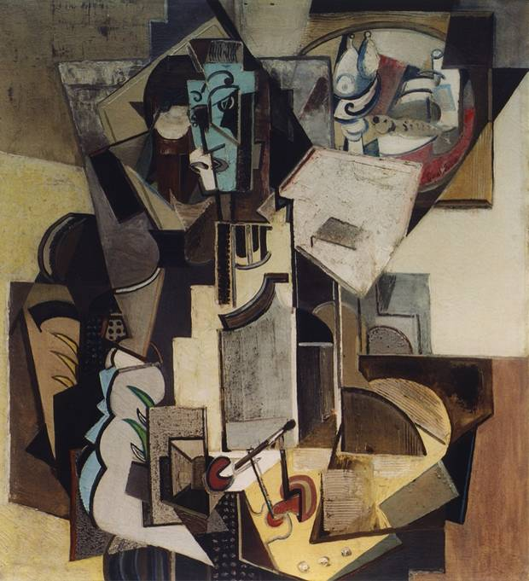 Emil Filla, Painter. Oil and sand on canvas, 98 x 90 cm. Vincenc Kramář collection. Image source: http://www.jirisvestka.com/vincenc-kramar

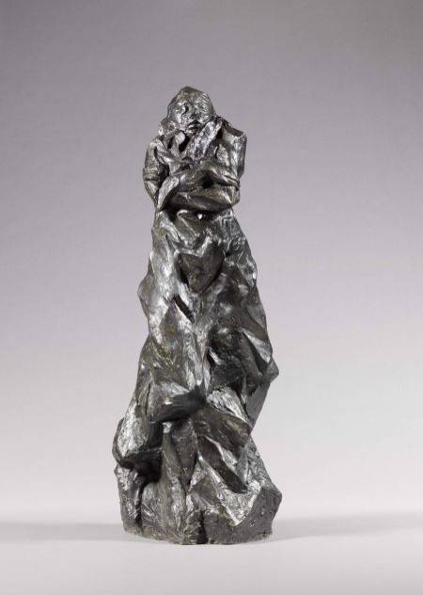 Otto Gutfreund, Anxiety, 1911 (exhibited at Skupina’s first exhibition in 1912). Muzeum Umění Olomouc. Image source: http://art.jib.cz/vuk/fotogalerie/muo/sbirky/muo9/view

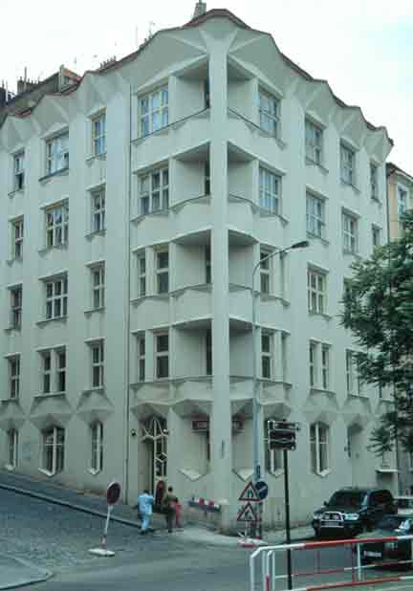 Josef Chochol, Apartment Building, 1913-14 at Neklanova ulice 98, in Vyšehrad, Prague. Image source: http://housingprototypes.org/project?File_No=CZ007

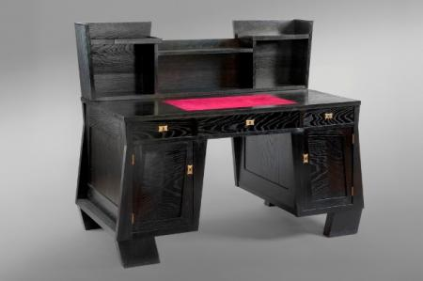 Josef Gočár, P.U. D., Writing Desk, 1914. photo: Ondřej Kocourek for UPM. Image source : http://www.upm.cz/index.php?page=123&year=stable&id=152&language=en

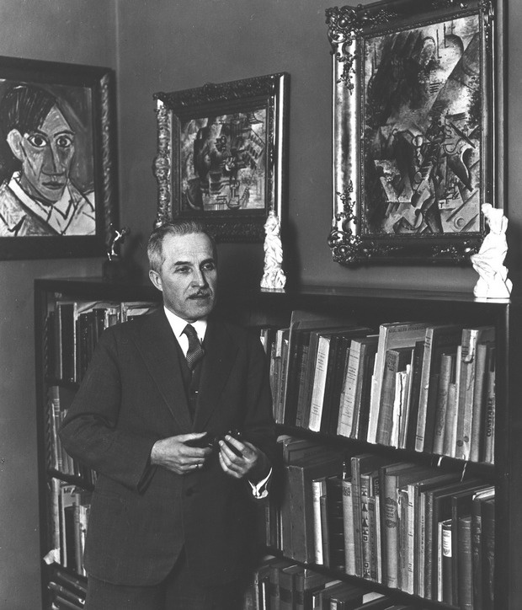 Vincenc Kramář with his collection of French Cubism
Image source: http://www.jirisvestka.com/vincenc-kramar

